1. **JUnit测试用例**

import org.junit.Test;import java.util.Random;import static org.junit.Assert.assertEquals;public class tritypTest { trityp tri=new trityp(); // Triang = 1 if triangle is scalene // Triang = 2 if triangle is isosceles // Triang = 3 if triangle is equilaterala // Triang = 4 if not a triangle @Test public void testTriang_4(){ assertEquals(4,tri.Triang(1,2,7)); assertEquals(4,tri.Triang(-1,2,7)); assertEquals(4,tri.Triang(-1,-2,7)); assertEquals(4,tri.Triang(1,-2,7)); assertEquals(4,tri.Triang(1,2,-7)); assertEquals(4,tri.Triang(1,7,2)); assertEquals(4,tri.Triang(7,1,2)); assertEquals(4,tri.Triang(2,2,4)); } @Test public void testTriang_3(){ assertEquals(3,tri.Triang(2,2,2)); } @Test public void testTriang_2(){ assertEquals(2,tri.Triang(2,3,2)); assertEquals(2,tri.Triang(2,3,3)); assertEquals(2,tri.Triang(2,2,1)); } @Test public void testTriang_1(){ assertEquals(1,tri.Triang(3,4,5)); }}

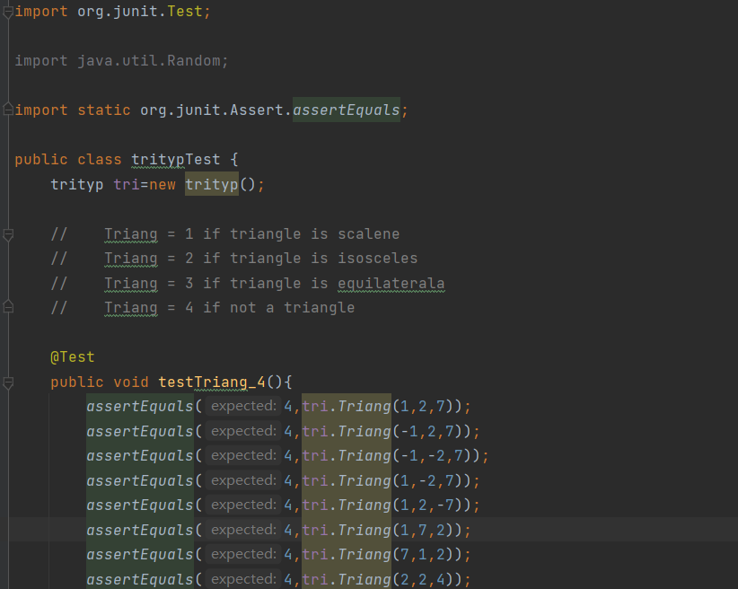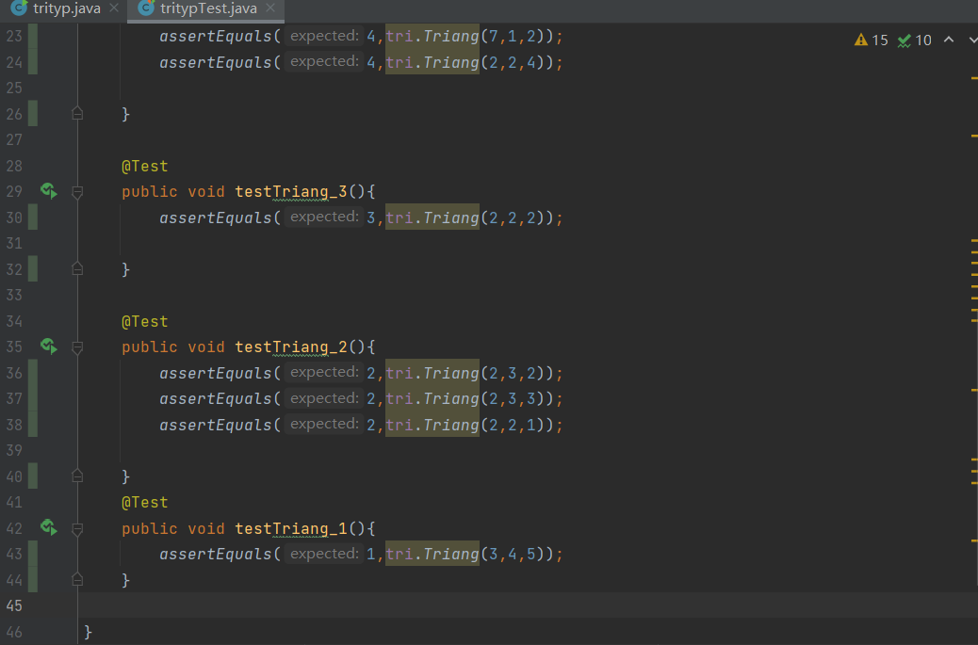

**（2）结果**

